Experiment – 2 Analysing Android App Permissions and Mobile Traffic

1. Aim
To analyse Android application network traffic and permissions by intercepting HTTP and HTTPS requests using an Android Emulator and Burp Suite.

2. Objective
- To create and run an Android Virtual Device (AVD).
- To configure a proxy between the Android Emulator and Burp Suite.
- To capture HTTP traffic from the Android device.
- To intercept and analyse HTTPS traffic by installing the Burp Suite CA certificate.

3. Required Tools / Software
- Android Studio
- Android Emulator (AVD Manager)
- Burp Suite
- ADB (Android Debug Bridge)
- Google Chrome (inside emulator)
- Internet connection

4. Procedure

Step 1: Create Android Virtual Device
- Install Android Studio.
- Open AVD Manager.
- Create a new Virtual Device.
Step-1: Download Android Studio->Create Virtual Device
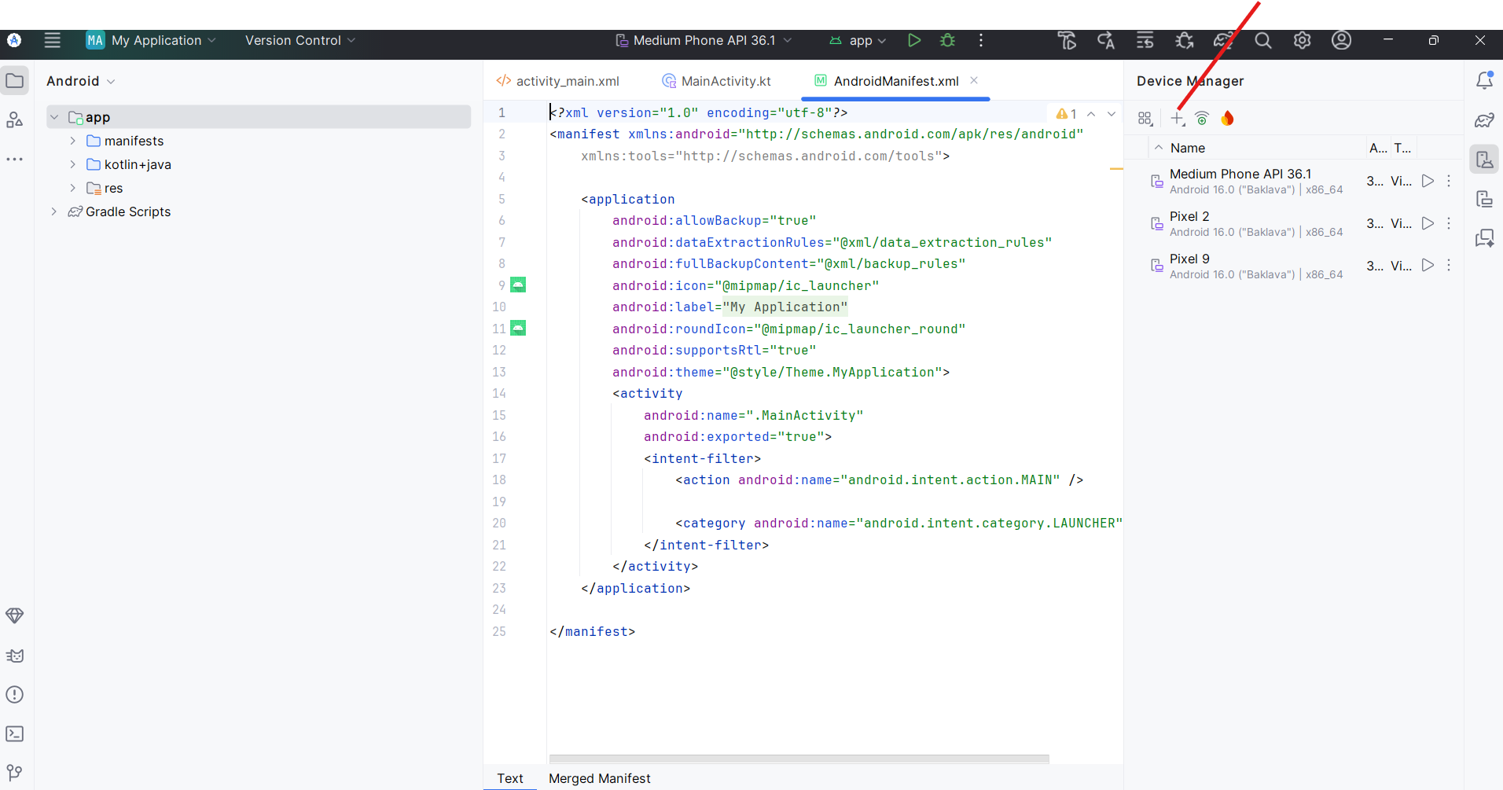

Step 2: Select Device
Choose any device such as:
- Pixel 2
- Pixel 9
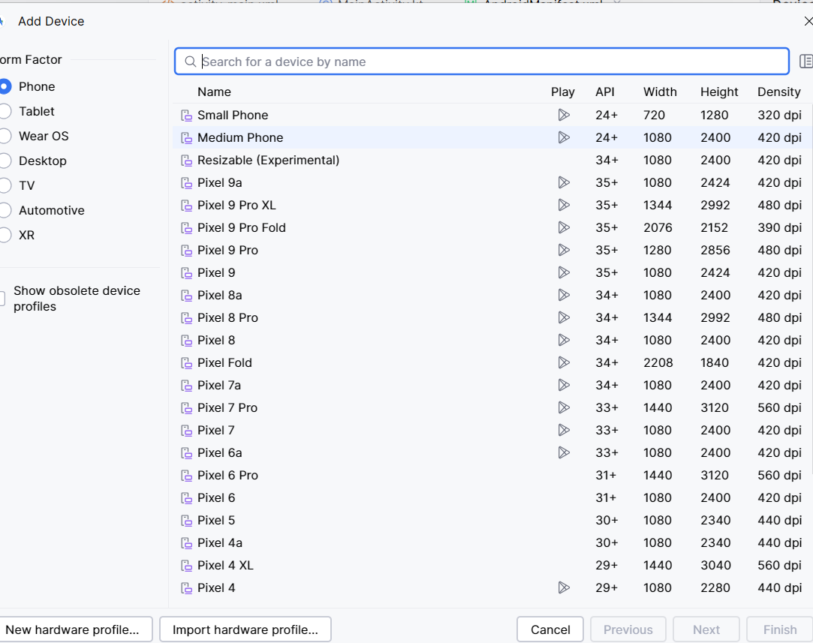

Step-3: Start AVD from Command Prompt1
C:\Users\Admin>cd C:\Users\Admin\AppData\Local\Android\Sdk\emulator
C:\Users\Admin\AppData\Local\Android\Sdk\emulator>emulator -list-avds
Medium_Phone_API_36.1
Pixel_2
Pixel_9
C:\Users\Admin\AppData\Local\Android\Sdk\emulator>emulator -avd Pixel_9 -http-proxy http://10.0.2.2:8080
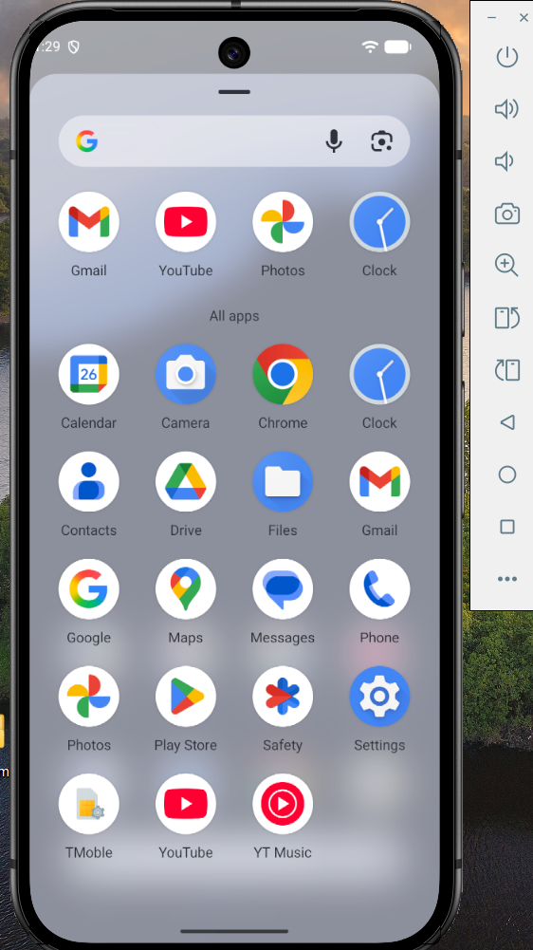

Step-4: Setup Proxy:
In AVD
Settings-> Network and Internet-> internet->select icon -> top right corner there is edit->advanced options -> proxy->Change proxy None->Manual->Hostname as 10.0.2.2 ->save
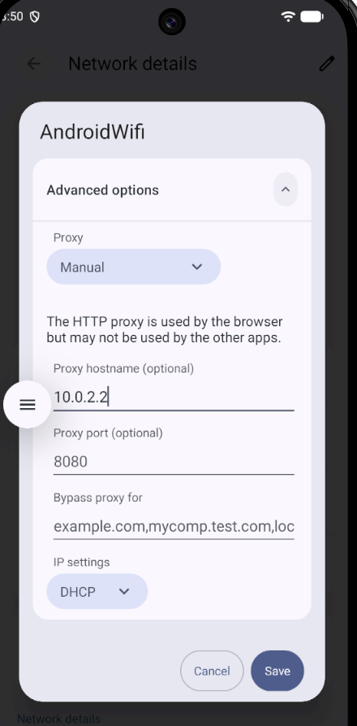
Note:if save option is not working then follow the steps in command prompt
Command Prompt2:
C:\Users\Admin>cd C:\Users\Admin\AppData\Local\Android\Sdk\platform-tools
C:\Users\Admin\AppData\Local\Android\Sdk\platform-tools>adb devices
List of devices attached
emulator-5554 device
C:\Users\Admin\AppData\Local\Android\Sdk\platform-tools>adb shell settings put global http_proxy 10.0.2.2:8080
C:\Users\Admin\AppData\Local\Android\Sdk\platform-tools>adb shell settings get global http_proxy
10.0.2.2:8080
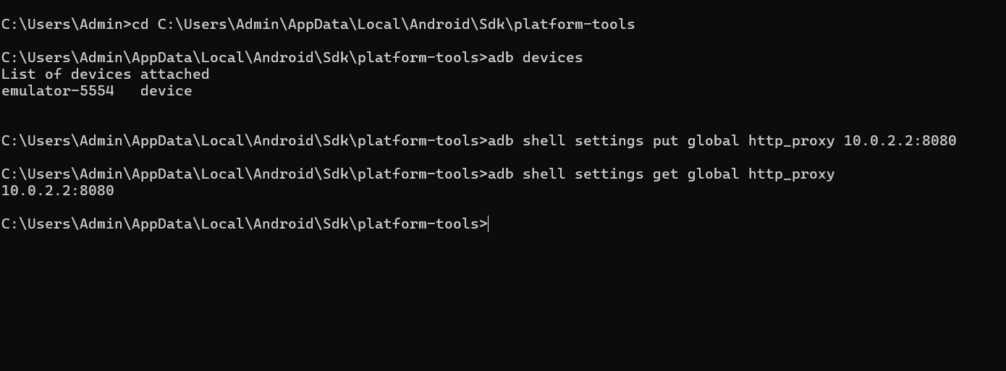
Step 5: In BurpSuit

Go procy->options/proxy settings->under Proxy Listeners->Edit->select All interfaces->ok
Go proxy->intercept on
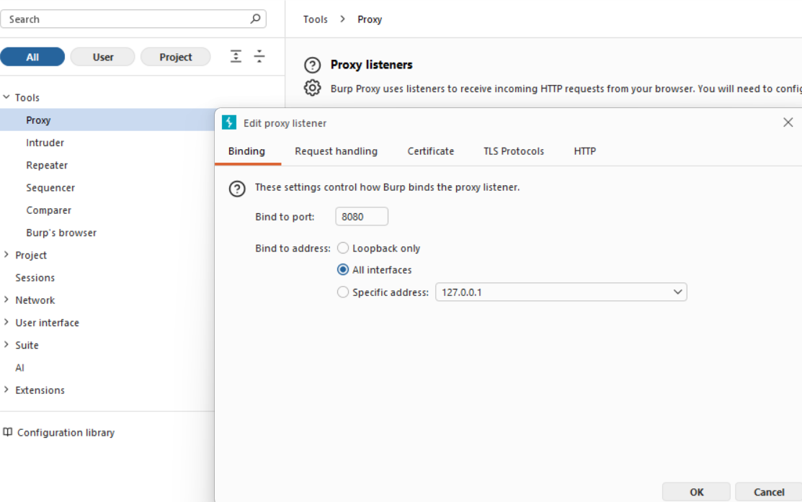
You can see BurpSuit is accepting all interfaces traffic
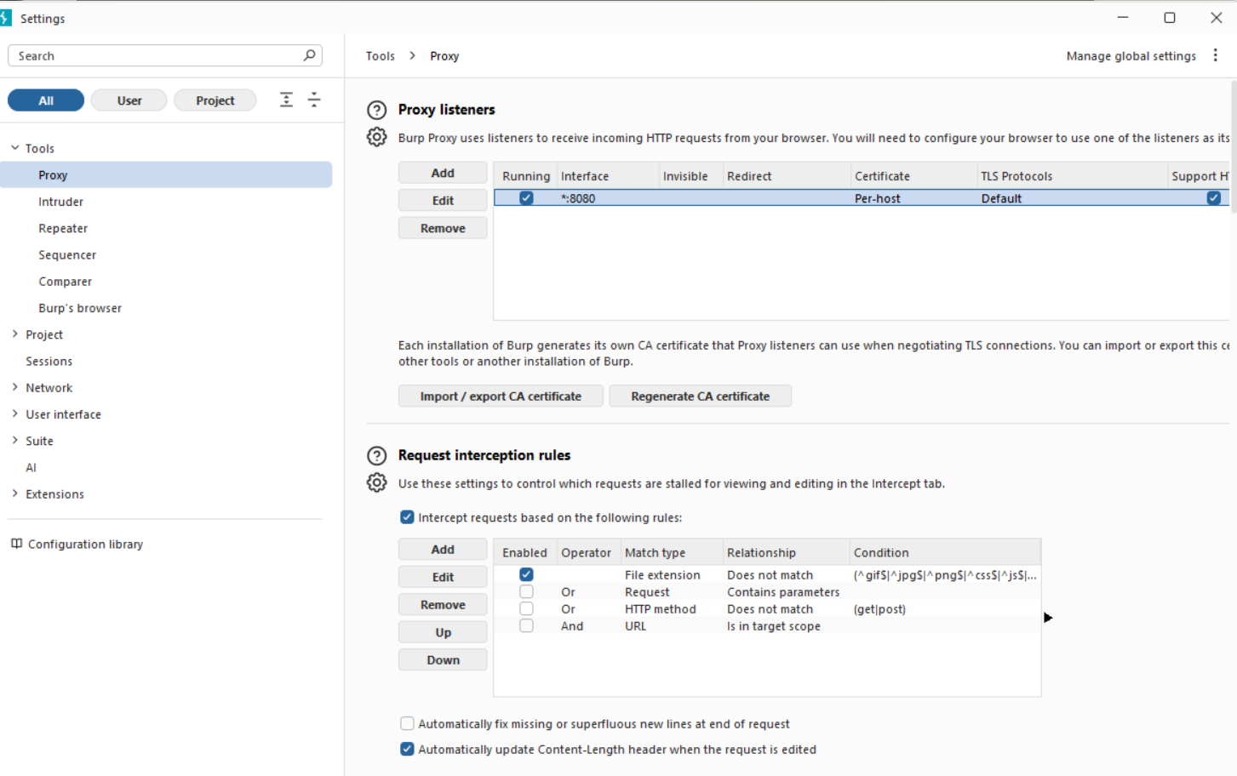
Step 6: in AVD type in chrome example.com and you can see burpsuit HTTP history
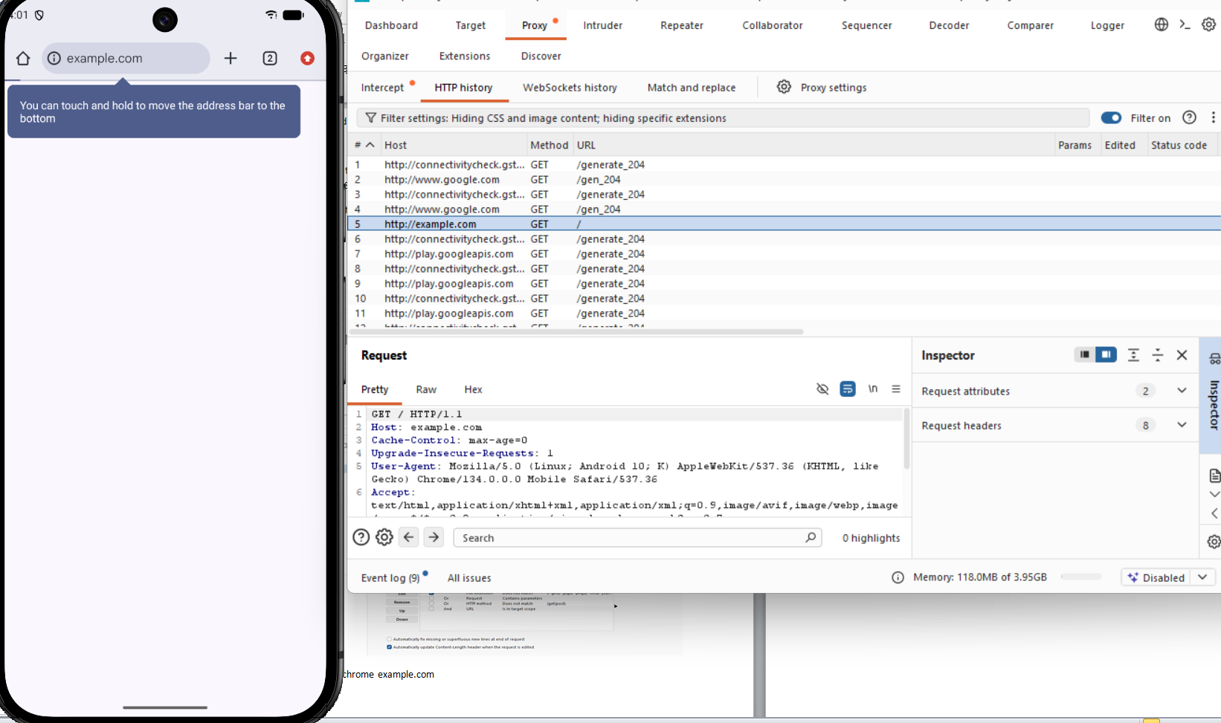

Step 7: in Step 5 we only able to http request and response only but if you want to analyse https request and response follow the Procedure to download CA certificate from BunrpSuit.
Go procy->options/proxy settings->import/export CA certificate->Certificate in DER format->select file-> Downloads->give name as burpcer.der
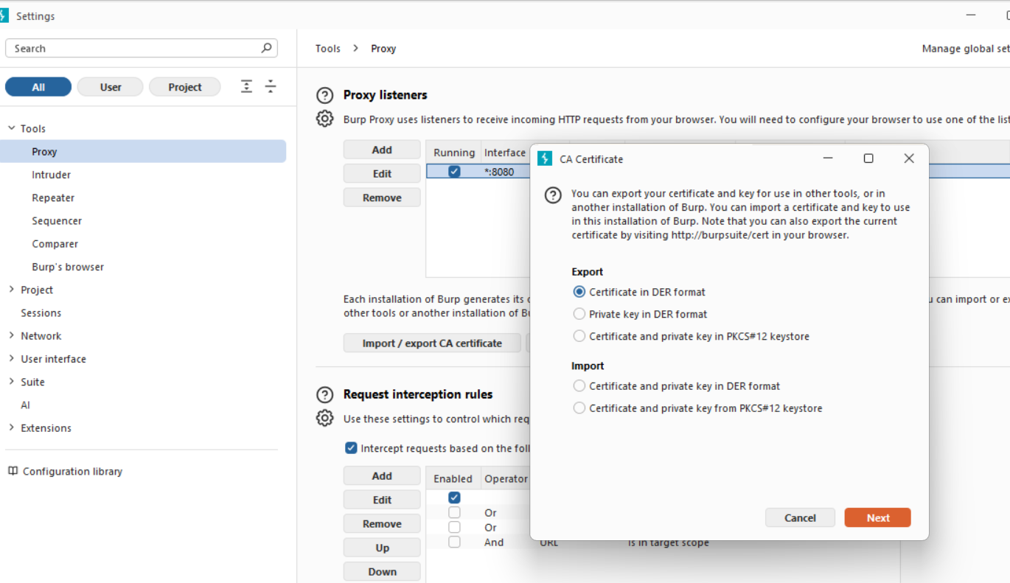
Step 8: Sending CA certificate to AVD
Go to command Prompt2
C:\Users\Admin\AppData\Local\Android\Sdk\platform-tools>adb push C:\Users\Admin\Downloads\burpcer.cer /sdcard/Download/
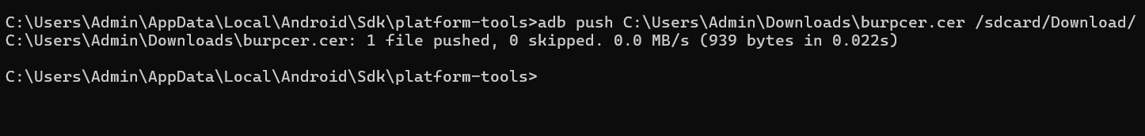

To install Certificate in AVD
Settings
→ Security & privacy
→ More security & privacy
→ Encryption & credentials
→ Install a certificate
→ CA certificate
In AVD we can see burpcer.der certificate
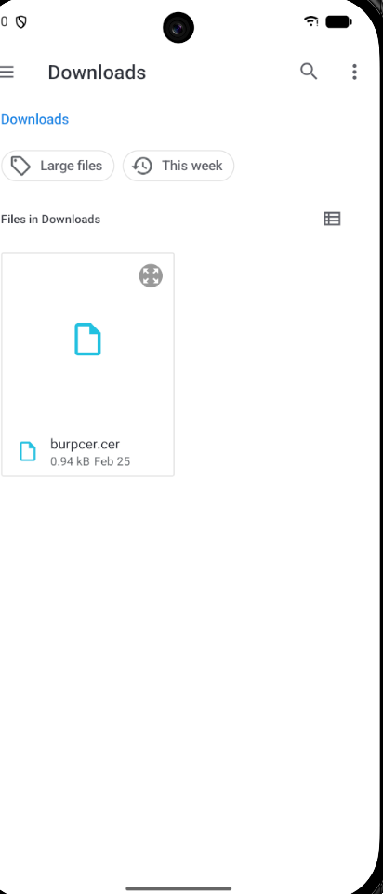

Step 9:verify HTTPS Interception
- Open browser in emulator.
- Visit any HTTPS website.
Example:
https://example.com
- In Burp Suite, check Proxy → HTTP History.
Now HTTPS requests and responses will be visible.

5. Result
Android application network traffic was successfully intercepted and analysed using Burp Suite by configuring proxy settings in the Android emulator and installing the Burp Suite CA certificate.

6. Precautions
- Ensure Burp Suite proxy port (8080) is correctly configured.
- Verify the emulator is running before executing ADB commands.
- Install the CA certificate properly to capture HTTPS traffic.
- Disable intercept when not required to allow traffic to pass normally.

